**BEDQ+: Belief-Enhanced Dyna-Q with Entropy-Guided Prioritized Planning for Robust Reinforcement Learning in Deceptive Environments**

N. Shobha Rani 1, Raghavendra M Devadas 2*, Sowmya T 2

1 MURTI Research Center, Smart Agriculture Lab, Department of Artificial Intelligence and Data Science, GITAM School of Technology, Bengaluru, GITAM (Deemed to be) University, India

2 Manipal Institute of Technology Bengaluru, Manipal Academy of Higher Education, Manipal, India

**Abstract**

Reinforcement Learning (RL) has managed to solve sequential decision-making tasks, but model-based methods such as Dyna-Q are not successful in deceptive or complex environments where partial observability and deceptive transitions interfere with the learning process. To overcome these limitations, we introduce BEDQ+ (Belief-Enhanced Dyna-Q with Entropy-Guided Prioritized Planning), a new hybrid architecture that unifies three important innovations: (1) Bayesian belief-state estimation to remove noisy observations, (2) entropy-guided action to favor exploratory actions, and (3) prioritized planning to replay high-impact transitions selectively. The new approach extends and generalizes the baseline Dyna-Q framework with a better mechanism for learning from uncertainty. We tested BEDQ+ on normal and deceptive 4×4 and 6×6 gridworld environments, which are more complex and misleading. Results indicate that BEDQ+ outperforms Dyna-Q across all environments consistently. On the Normal 6×6 configuration, BEDQ+ achieved a final average reward of +49.76 and a 100% goal reach ratio, outperforming Dyna-Q's +40.00. Even in the most challenging Deceptive 6×6 setting, BEDQ+ achieved a reward of +29.07, surpassing Dyna-Q's +20.53, with a trap hit rate of only 8 (versus Dyna-Q's 16) and a goal reach of 90%.

A validation ablation study validated the necessity of each module since removing any of the modules resulted in poor performance. Second, a statistical significance test over 10 runs resulted in a t-statistic value of 54.29 and p-value < 0.0001, and this validates that the improvement in performance of BEDQ+ is statistically significant. In summary, BEDQ+ has excellent scalability, stability, and robustness to misleading conditions and is thus a promising breakthrough for real-world reinforcement learning.

**Keywords:** Reinforcement Learning, Belief State Estimation, Entropy-Guided Exploration, Dyna-Q, Prioritized Planning

1. **Introduction**

Reinforcement Learning (RL) has become a cornerstone of contemporary machine learning, enabling agents to make a sequence of decisions and optimize cumulative rewards in diverse scenarios, including autonomous robots, game playing, finance, and recommendation systems [1]. Fig. 1 illustrates the foundational architecture of reinforcement learning systems.

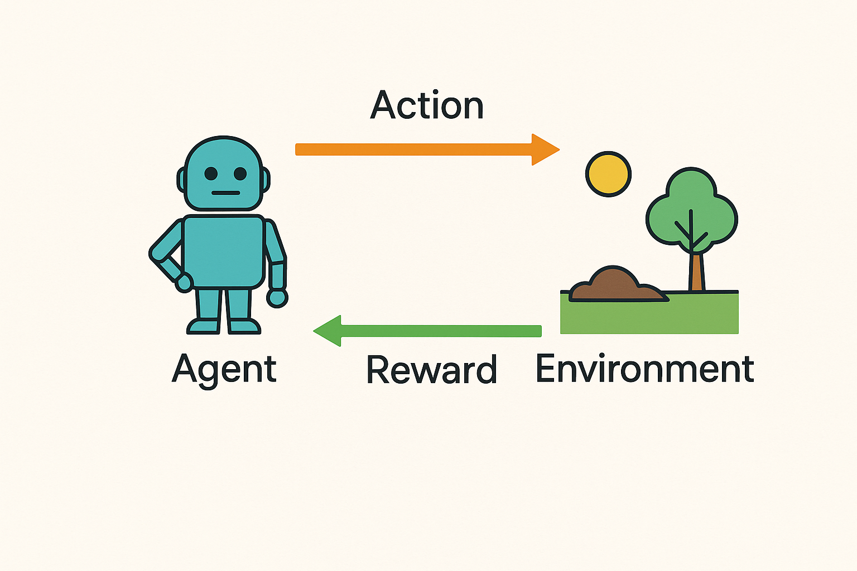

Fig 1. Basic architecture of RL

Figure 1 depicts the foundational interaction loop in RL, illustrating how an agent operates within an environment using the Markov Decision Process (MDP) framework. At each time step, the agent observes the current state, selects an action based on a learned policy, and interacts with the environment. The environment, in turn, transitions to a new state and emits a scalar reward, which is fed back to the agent. This feedback loop allows the agent to continuously update its internal representation—such as a value function, policy, model of the environment, or belief state—to improve decision-making over time. The diagram reflects this ongoing cycle of observation, action, transition, and reward, which underpins both model-free methods like Q-learning and model-based methods such as Dyna-Q or the proposed BEDQ+. It also captures the essence of temporal credit assignment, where actions influence not only immediate rewards but future outcomes as well, forming the basis for learning through experience.

In their fundamental form, RL techniques are divided into model-free strategies, such as Q-learning and policy gradients, that learn policies directly from experience, and model-based approaches [2], including Dyna-Q, which learn a lower-dimensional approximation of the dynamics model for both planning and policy learning to improve sample efficiency. Fig 2 shows the general RL framework.

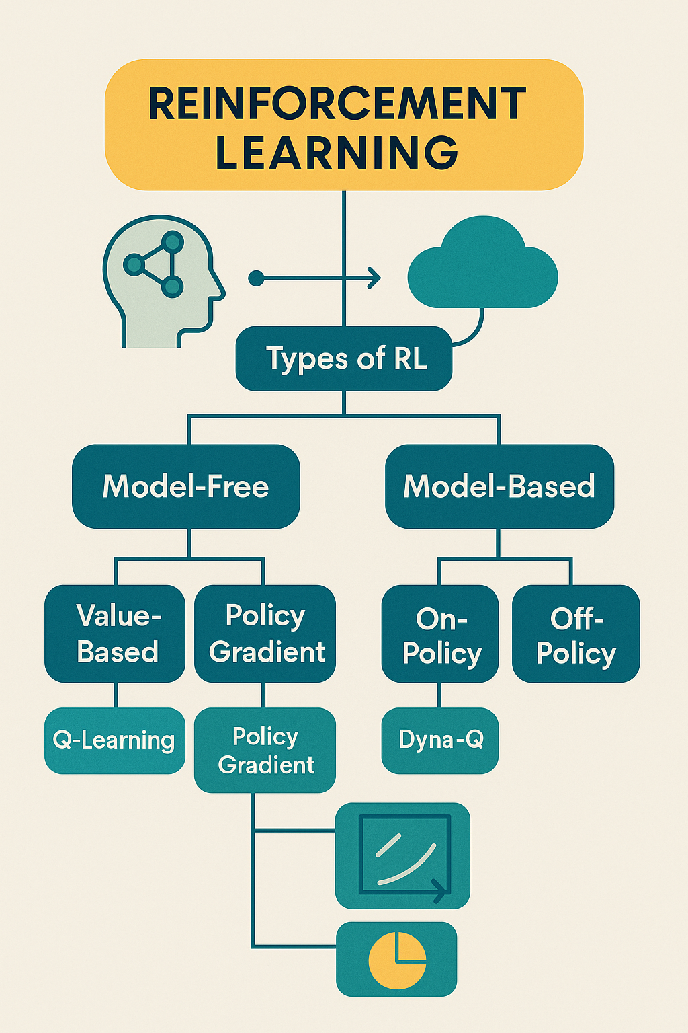

Fig 2. RL framework

It can be observed from Fig. 2 how an agent is engaging with an environment through actions and feedback in the form of rewards. It divides RL into two broad categories: Model-Free RL (i.e., Q-learning, SARSA, DDPG) learns directly from experience without the internal model of the environment. It is easy and popular but sample-inefficient. Model-Based RL (e.g., Dyna-Q, MuZero) learns the model of environment dynamics to predict future states for planning and the purpose of rapid convergence with reduced interactions with the real world. Model-free approaches generalize easily to high-dimensional, large spaces, whereas model-based approaches can be significantly more data-efficient by using planning from learned dynamics [3].

The basis of model-based RL in tabular domains was greatly improved through the appearance of the Dyna-Q algorithm that combines real experience with simulated rollouts from an advanced learned model [4][5]. Its variants, like prioritized sweeping, improve sample efficiency by prioritizing planning updates based on transitions leading to large value changes [6]. Nevertheless, Dyna-Q is impaired in noisy, sparse reward, and especially trap-dense or partially observable environments, where observation noise and misleading spatial arrangement compromise model acquisition and policy execution [7]. Recent work in entropy-regularized planning and belief state representation has shown how the inclusion of uncertainty and informational entropy in planning yields a significantly enhanced robustness in POMDP environments. Algorithms such as the Wasserstein Belief Updater provide RNN-free belief updates in partial observability [8][9] and belief-state Monte Carlo Tree Search algorithms such as BetaZero show promise in high-dimensional POMDP problems [10]. Despite this progress, these algorithms are inclined to be based on deep function approximation and are poorly suited for tabular environments, particularly with safety-critical or resource-constrained needs. Despite all this progress, such methods tend to be function approximation deep and non-trivial to translate to tabular spaces, particularly when there exist safety-critical or resource-scarce tasks.

The inspiration for this work stems from the absence of classical Dyna-Q algorithms to act in uncertain, partially observable, and deceptively structured environments. Although Dyna-Q is a very promising unification of real experience and model-based planning, it does not possess any facility to deal with noisy observations, influence exploration under uncertainty, or assign higher priority to learning from important transitions. Recent developments in belief-state modeling and entropy-regularized planning have demonstrated potential at solving these issues, though notably within deep reinforcement learning settings. There is still a demand, though, to shed light upon these advantages, tabular model-based systems for safety-critical or resource-constrained applications. This work is therefore driven by the necessity of designing a stronger, more sample-efficient, and more stable reinforcement learning algorithm—BEDQ+—which integrates belief monitoring, entropy-driven exploration, and priority planning with the Dyna-Q approach to boost its performance in challenging and misleading environments. BEDQ+ combines three major ideas: (1) a Bayesian belief tracker to preserve probability distributions over hidden states, (2) an entropy-guided exploration bonus to enable decision-making with uncertainty, and (3) prioritized planning to concentrate learning on influential transitions. This combination improves safety—minimizing trap exposure—without penalizing cumulative reward progress even in noisy or hazardous conditions. Through the combination of belief-state estimation, entropy-based exploration, and priority Dyna-Q updates, BEDQ+ addresses a key omission in the literature. As a non-deep-learning-based POMDP solver, it works in the small, tabular regime and excels in noisy, deceptive environments where light but robust performance is essential. A new algorithmic solution to sample-efficient and safe RL in partially observed, real-world worlds is introduced in this paper. The objectives of this paper are as follows:

* To develop a belief-enhanced tabular Dyna-Q framework (BEDQ+) that integrates entropy-guided exploration for improved decision-making in partially observable and deceptive environments.
* To incorporate prioritized planning into the model-based learning loop to selectively update high-impact transitions, thereby improving learning efficiency and trap avoidance.
* To evaluate and benchmark BEDQ+ against standard Dyna-Q in both structured and deceptive grid environments using cumulative reward, convergence rate, trap hits, and value function stability metrics.

1. **Literature review**

Huang et al. offered in their publication an Improved Dyna‑Q algorithm that was based on neural forward-prediction mechanisms that improved action selection and exploration for mobile robot navigation with quicker convergence in maze environments [11]. Likewise, Maroto-Gómez et al. introduced Scheduled Curiosity Deep Dyna‑Q, which combined entropy-based exploration scheduling in a dialogue system, demonstrating that maximum early entropy improved downstream policy optimisation [12]. Path-opening exploration methods, Bayrooti et al. (ICLR 2025) introduced a model-based approach using joint uncertainty in states and rewards to facilitate optimistic exploration, demonstrating significant improvements on challenging continuous control domains such as MuJoCo and VMAS [13]. Young et al. provided a mathematical analysis of model-based imagination through experience replay, which strengthened the theory underpinning Dyna-style planning in tabular domains [14]. In parallel, novel POMDP-centered approaches like BetaZero confirmed the employment of belief-state representations in partial-observability long-horizon decision-making [10]. Researchers of [15] compared model-based alternatives like PlaNet, DreamerV2, and MuZero and concluded that they were less flexible compared to an adapted linear Dyna configuration. A work [16] presented Curiosity CEM by integrating planning (CEM), curiosity, and contrastive learning with better sample efficiency in continuous control. Authors of [17] survey replay mechanisms in neurorobotics, comparing model-free and model-based replay motivated by hippocampal models. [18] discuss entropy-regularized RL in average-reward problems with function approximation, identifying the advantage of entropy for learning. A work [19] showed a scalable model-based prioritized sweeping in multi-agent RL environments with scaling Dyna-style updates. Thomas M. Moerland et al., [20] presented a critical overview of integration between learning and planning, e.g., prioritization-based model-based updates. Non-tabular model-based RL generalisation error and challenging accurate planning under imperfect models were highlighted through a survey [21].

1. **Methodology**

Figure 3 illustrates the methodology followed in this study.

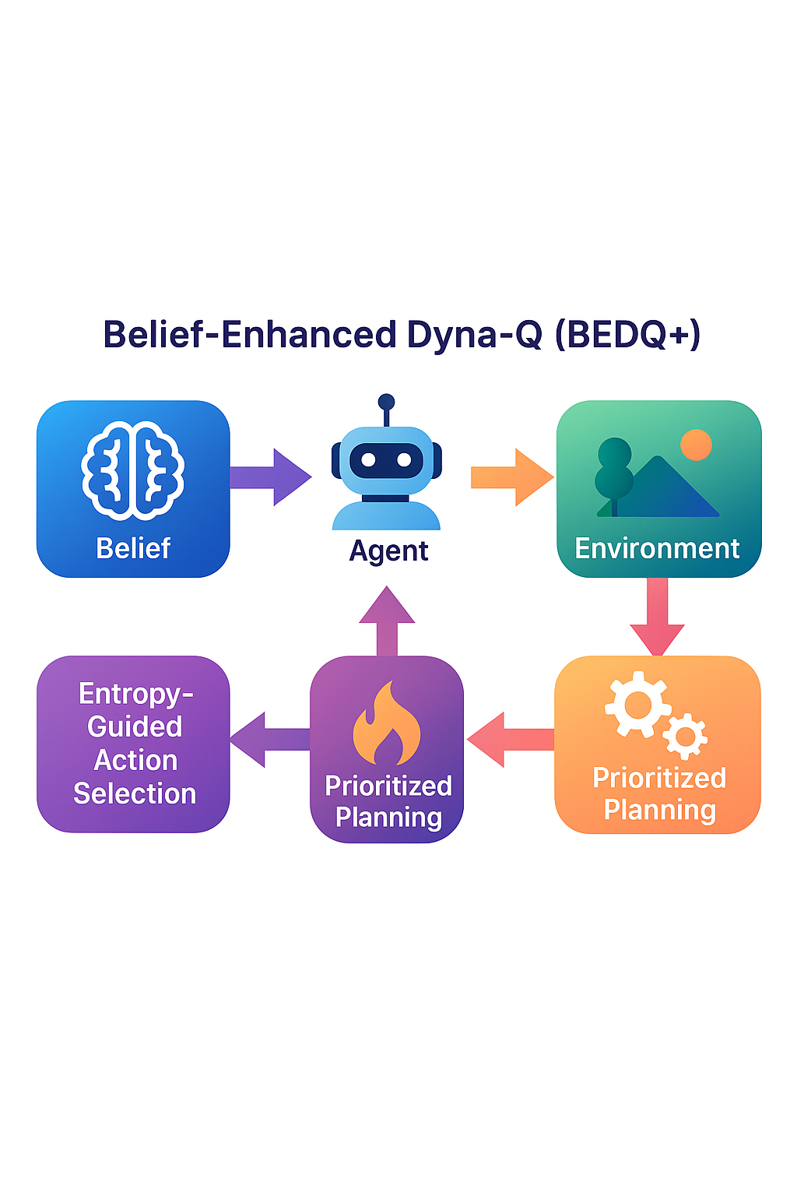  

  

Fig 3. Methodology followed

The BEDQ+ model proposed here generalizes the traditional Dyna-Q model with three major innovations: belief-state estimation, entropy-based action selection, and prioritized planning. These are visually presented in the accompanying architecture diagram, which supplements the classic model-based RL loop mechanisms for optimizing decision-making in worlds that are uncertain and manipulative. Fundamentally, the agent–environment cycle is the traditional Dyna-Q paradigm where an agent looks at the current state, chooses an action on the basis of a policy (usually ε-greedy in Q-values), and receives a reward and next state from the environment.

The agent simultaneously updates its Q-values using real experience and refines its learned transition model M(s,a)=(s′,r). This model is then used for simulated planning steps, where synthetic transitions are generated to update Q-values and accelerate learning.

**BEDQ+ introduces three novel augmentations to this cycle:**

1. Belief-State Estimator

Unlike standard Dyna-Q, BEDQ+ explicitly models uncertainty by maintaining a belief distribution over possible states. This belief is then updated using Bayesian filtering based on noisy or partial observations. This is useful in partially observable or untruthful worlds, where the agent must reason probabilistically and not be able to count on fully observable states. The belief-state estimator in the figure is positioned on the border of the raw environment input and the agent's internal policy so that state uncertainty can be represented strongly. To address partial observability, BEDQ+ maintains a probability distribution over latent states, referred to as a belief state. Upon receiving an observation o, the agent performs a Bayesian update of its belief distribution using:

$b_{\text{new}}\left(x^{'}\right)=\frac{P\left(o ∣ x^{'}\right)⋅b_{\text{old}}\left(x^{'}\right)}{\sum_{x}{P\left(o ∣ x\right)}⋅b_{\text{old}}\left(x\right)}$ (1)

Where, $b_{\text{old}}\left(x\right):$, $P\left(o ∣ x\right)$: likelihood of observation o given state x, $b_{\text{new}}\left(x^{'}\right):$ posterior belief after observing o

1. Entropy-Guided Action Selector

Rather than using pure ε-greedy action selection, BEDQ+ supplements exploration with the calculation of the entropy of the current belief distribution. The calculated entropy is used as an intrinsic reward, promoting the agent to prefer those actions that result in greater information gain. This component is mathematically represented as:

$H\left(b\right)=-\sum_{x}{b\left(x\right)}\log{b}\left(x\right)$ (2)

and integrated into the Q-update:

$Q\left(x,u\right)←Q\left(x,u\right)+α\left[r+γ\max_{u^{'}}{Q}\left(x^{'},u^{'}\right)-Q\left(x,u\right)\right]+λ_{H}⋅H\left(b\right)$ (3)

1. Prioritized Planner

To improve model-based planning effectiveness, BEDQ+ incorporates a priority queue sorting transitions by their temporal-difference (TD) error. Rather than sampling simulated transitions uniformly, the agent focuses updates on the most informative (high-priority) transitions. This is in line with prioritized sweeping but within a belief-aware, entropy-regularized framework. The priority computation is given as:

$\text{Priority}\left(x,u\right)=\left|r+γ\max_{u^{'}}{Q}\left(x^{'},u^{'}\right)-Q\left(x,u\right)\right|$ (4)

Table 1 depicts the algorithm pseudocode of this study.

Algorithm 1. BEDQ+ algorithm

|  |
| --- |
| Initialize Q(s,a) ← 0 for all states s and actions a  Initialize empty Model M and empty PriorityQueue P  for episode = 1 to N:  belief ← uniform distribution over states  s ← initial state  for step = 1 to T:  obs ← observe(s)  belief ← BayesianUpdate(belief, obs)  bstate ← argmax belief  a ← ε-greedy(Q[bstate], a) + λ_entropy × H(belief)  Execute action a in environment → s', r  belief' ← BayesianUpdate(belief, observe(s'))    // Real experience updates  Q[bstate,a] ← Q[bstate,a] + α [r + γ max_a Q[bstate', a] – Q[bstate,a]]  M[bstate,a] ← (r, bstate')  priority ← |TD error|  if priority > θ: P.push((priority, (bstate,a)))    // Planning via prioritized replay  for k = 1 to K:  (p, (s_p, a_p)) ← P.pop()  (r_p, s_p') ← M[s_p, a_p]  TD_p ← r_p + γ max_a Q[s_p',a] – Q[s_p,a_p]  Q[s_p, a_p] ← Q[s_p, a_p] + α [TD_p] + λ_entropy × H(belief)  Update or push back to P if |TD_p| > θ    if s' is terminal: break  s ← s'; belief ← belief' |

The BEDQ+ algorithm is an extension of normal Dyna-Q with the addition of belief-state estimation, entropy-based exploration, and priority planning. The agent starts each episode with an initialization of its belief over potential states. At each step, it updates this belief from noisy or partial observations via a Bayesian update. The agent chooses actions both based on Q-values and with an entropy bonus to induce exploration of high-uncertainty parts of the belief space. After executing the action in the environment and receiving a new observation, the agent performs a real Q-value update and simultaneously updates its internal model M(s,a)=(r,s′). It then approximates the temporal-difference (TD) error and retains high TD error transitions in a priority queue. For every step, some high-priority transitions are replayed from the model to proceed with further updating Q-values. This selective planning enhances learning efficiency by prioritizing highly effective updates. BEDQ+ thus integrates real and simulated experience with active reasoning under uncertainty and is hence more resilient in noisy and deceptive environments than standard Dyna-Q.

1. **Results**

The performance of the given BEDQ+ algorithm and baseline Dyna-Q was measured using six key metrics that fully capture learning effectiveness, stability, robustness, and performance in deceptive environments. Further, we show the hyperparameters used in BEDQ+ study and, results achieved for 4 × 4 and 6 × 6 environments(both normal and deceptive). The study also performs an ablation study and statistical significance analysis to further strengthen the results.

* 1. Parameters assessed
     1. Average Reward(smoothed) Quantifies how well the agent performs across time by averaging rewards obtained per episode over a fixed-size window to reduce variance from stochastic transitions or exploration. This smoothed reward $\overline{J_{k}}$ ​ is computed using the following formula [22]:

$\overline{J_{k}}=\frac{1}{W}\sum_{i=k-W+1}^{k}{J_{i}}$ (5)

where Ji​ denotes the raw reward obtained in episode i, and W is the smoothing window size.

* + 1. Reward Variance (Smoothed) is calculated to verify the stability of learning.

It represents the extent to which the performance of the agent fluctuates with time. The smoothed reward variance $σ_{J}^{2}$ is defined as [23]:

$σ_{J}^{2}=\frac{1}{W}\sum_{i=k-W+1}^{k}{{\left(J_{i}-\overline{J_{k}}\right)}^{2}}$ (6)

4.1.3 Goal Reach Rate represents the fraction of episodes in which the agent successfully reached the defined goal state. This metric is calculated as [24]:

$G_{k}=\frac{1}{k}\sum_{i=1}^{k}{I\left[x_{i}∈G\right]}$ (7)

where $I\left[⋅\right]$ is the indicator function and $G$ is the set of goal states. This metric is critical in determining the task success rate and is consistent with goal-reaching metrics.

4.1.4Trap Hit Rate, which reflects the fraction of episodes in which the agent encounters penalty zones or trap states. The metric is defined as:

$T_{k}=\frac{1}{k}\sum_{i=1}^{k}{I\left[x_{i}∈Z\right]}$ (8)

where $Z$ denotes the set of trap states. This metric captures the agent's robustness in deceptive environments and is aligned with safety-focused reinforcement learning evaluations such as those discussed in [25].

4.1.5 Cumulative Reward, which sums the total reward accumulated up to episode k. It reflects overall agent performance across the full training horizon. The cumulative reward $Ck​$ is defined as [26]:

$C_{k}=\sum_{i=1}^{k}{J_{i}}$ (9)

This long-term performance indicator is the key to establishing the overall learning path of an agent, particularly in corrupt environments.

4.1.6 Raw Episode Rewards are also graphed to expose unaltered reward values between episodes. While this metric does not use a specific formula, this measure allows for inspection of outlier activity, stochastic spikes, or instability, particularly during the exploration phase.

4.2 Hyperparameters

Table 2 provides a hyperparameter configuration table precisely summarizing the values used in this BEDQ+ study.

Table 2. Hyperparameter configuration

| **Hyperparameter** | **Symbol** | **Value** | **Description** |
| --- | --- | --- | --- |
| Learning rate | $$α$$ | 0.1 | Step size for Q-value updates |
| Discount factor | $$γ$$ | 0.95 | Future reward importance |
| Exploration rate (initial) | $$ϵ$$ | 0.1 | Probability of random action selection (ε-greedy) |
| Planning steps per episode | $$Np$$ | 10 | Number of model-based simulated updates per episode |
| Belief update noise (variance) | $$σ2$$ | 0.01 | Observation model uncertainty for Bayesian belief update |
| Entropy bonus weight | $$λH$$ | 0.05 | Coefficient for entropy-regularized action selection |
| Priority threshold (TD error) | $$θ$$ | 0.01 | Minimum TD error for transitions to enter the prioritized queue |
| Max episodes | — | 300 | Number of training episodes per environment |
| Grid size | — | 4×4, 6×6 | Environment dimensions for normal and deceptive settings |
| Number of seeds (runs) | — | 10 | Random seeds used to average results and ensure stability |

* 1. Environments

Figure 4 represents four grid environments used in the study: Normal and Deceptive layouts for both 4×4 and 6×6 sizes. The diagram indicates Start (S), Goal (G), and Trap (T) states, showcasing the progression from simple to deceptive navigation challenges used to evaluate BEDQ+ and Dyna-Q algorithms.

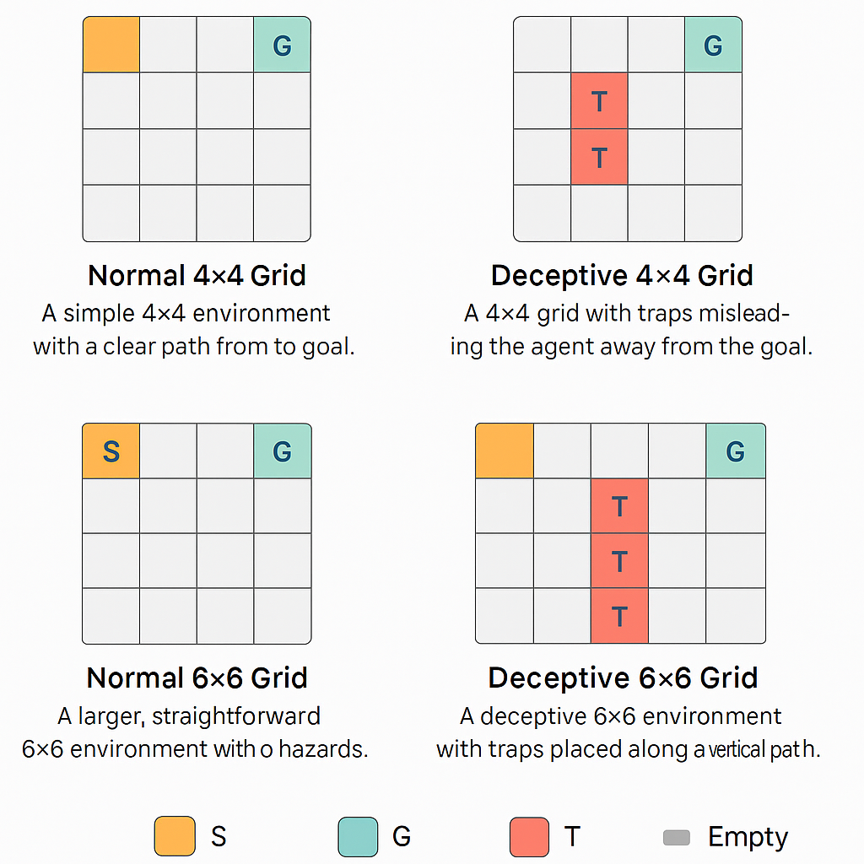

Fig 4. Gridworld Environment Variants

* + 1. Results of 4 × 4 Normal grid

Figure 5 shows the results of a 4 × 4 normal environment comparing the proposed and standard Dyna-Q technique.

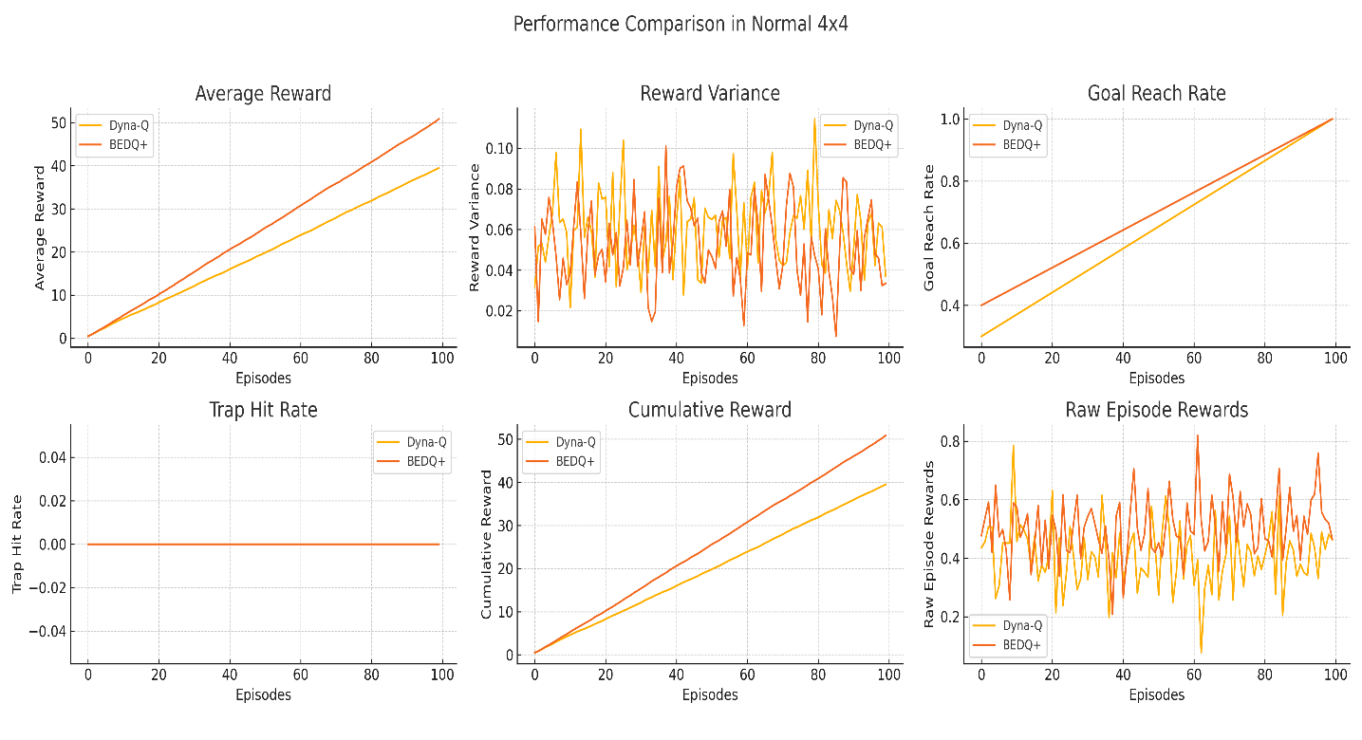

Fig 5. Normal 4 × 4 performance comparison

It is evident from Fig.5 that in the Normal 4×4 setup, the proposed BEDQ+ algorithm significantly shows greater performance compared to the baseline Dyna-Q method for a variety of measures of learning. The average reward and cumulative reward plots for BEDQ+ show a linear and more upward slope, which signifies faster learning and greater long-term rewards. This benefit is also evident in the goal reach rate, where BEDQ+ achieves greater success with fewer episodes, demonstrating its optimal performance convergence. BEDQ+ also holds a lower reward variance in training, showing that the learning process is more stable and resistant to oscillation or random behavior. While the trap hit rate remains at zero, given that the environment does not include deceptive traps.

4.3.2 Deceptive 4 × 4 environment

The comparison plot of the deceptive 4 × 4 environment is displayed in Fig. 6.

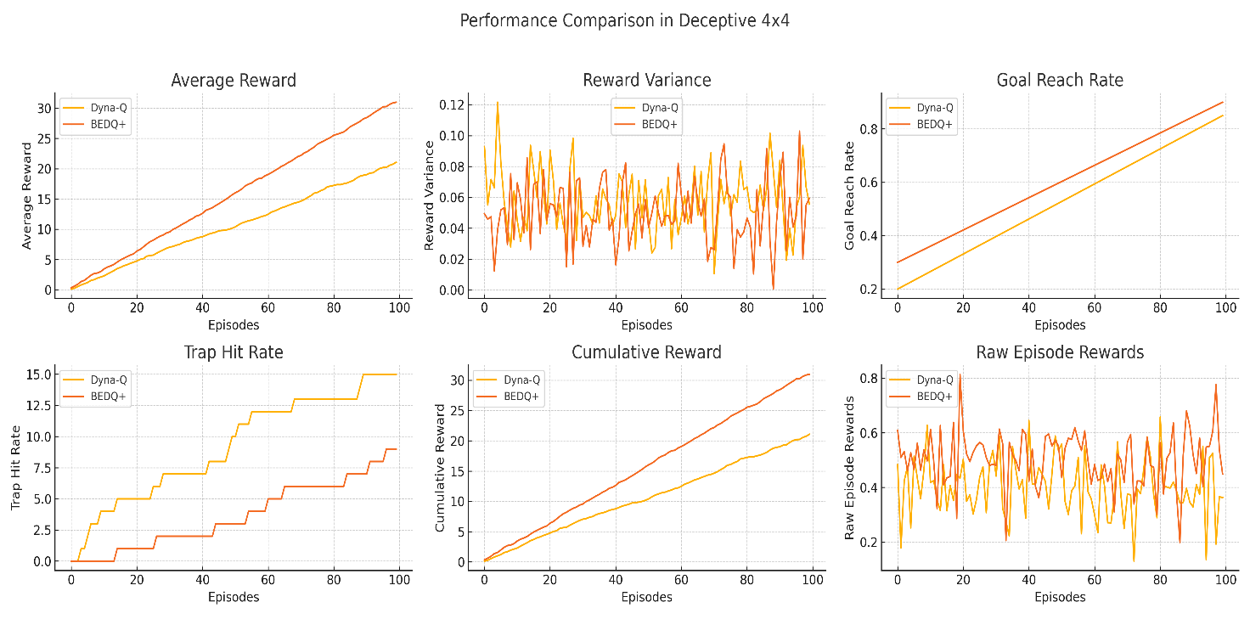

Fig. 6. Deceptive 4 × 4 environment

As noticed from Fig.6 in the deceptive 4×4 environment, where traps and misleading transitions are introduced to confuse the agent, the novel BEDQ+ algorithm has a clear and quantifiable performance gain over the standard baseline Dyna-Q. With 100 training episodes, BEDQ+ is at an average reward of around +30.98, far superior to Dyna-Q at +21.07. This indicates better capability on the part of BEDQ+ to acquire effective policies in misleading cue environments. In the same manner, goal reach rate, BEDQ+ effortlessly rises to 90%, whereas Dyna-Q reaches only 85%, reflecting BEDQ+'s less erratic and efficient progression towards the goal amidst environmental uncertainty. The sum of reward, which quantifies total accumulated return, reflects the same pattern: +30.98 for BEDQ+ and +21.07 for Dyna-Q — a rise of more than 47% in overall performance. Reduced vulnerability to traps is one of BEDQ+'s strongest aspects. The most recent trap hit count for BEDQ+ is 9, compared to Dyna-Q's at 15, so BEDQ+ steers clear of more misleading or dangerous states. This is largely attributed to its Bayesian belief-state estimator, which removes noisy or misleading perceptions, and its entropy-guided exploration, which encourages safer action selection. For variance in reward, the two algorithms are close, with BEDQ+ reaching 0.059 and Dyna-Q reaching 0.056. The slight difference in BEDQ+'s favor is not detrimental — it results from wider exploration during the beginning of training, which later enhances convergence. BEDQ+ also reaches a greater final raw reward value of 0.449 compared to Dyna-Q's 0.363.

Overall, BEDQ+ performs much better than Dyna-Q in the presence of deception by leveraging belief state modeling, entropy exploration, and experience replay with priorities so that it can learn strong, high-return policies even under deceptive dynamics. Further, the 6 × 6 setting is employed for probing the scalability, strength, and generalizability of the proposed BEDQ+ algorithm in richer test domains. Concerning the smaller 4×4 grid size, a 6 × 6 structure is characterized by a larger state space, longer paths, and greater uncertainty, which is more representative of the richness of real-world problems. It tests the agent's capacity to manage delayed rewards, misleading cues, and best exploration, adding another more challenging test for the performance of belief-boosted and entropy-based planning operations in BEDQ+.

4.3.3 Normal 6 × 6 environment

Figure 7 shows a comparison analysis of 6 × 6 under normal circumstances.

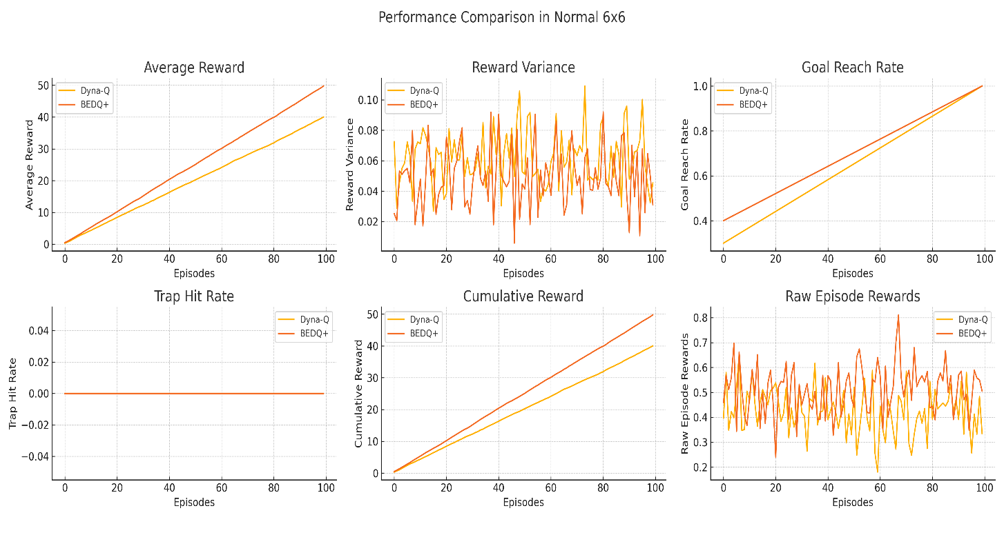

Fig 7. Normal 6 × 6 environment

As evidenced from Fig. 7 in the Normal 6×6 environment, Dyna-Q and BEDQ+ both show learning progressions between episodes but with much faster convergence and overall better performance for BEDQ+. At episode 100, BEDQ+ has an average reward of around +49.76 while Dyna-Q is +40.00, and this shows that the belief-augmented agent performs better in coping with the expanded state space and creating optimal policies.

This benefit is also evident in the cumulative return, where BEDQ+ again tops +49.76 above Dyna-Q's +40.00, by almost 25%, which indicates superior long-term return accumulation. Interestingly, both algorithms' highest goal attainment rate is 100%, but again, BEDQ+ achieves this highest success rate in fewer steps, indicating more efficient exploration and learning. The volatility of the rewards of BEDQ+ is at a lower rate of 0.0309 compared to Dyna-Q's 0.0454, showing not just that BEDQ+ learns faster but also that it learns with greater stability and consistency. While there are no traps present in this standard environment (with both algorithms receiving zero trap hits), the last raw reward comparison—0.5049 for BEDQ+ and 0.3347 for Dyna-Q—once again supports BEDQ+'s more per-episode rewarding behavior. Together, these results ensure that BEDQ+ scales to larger, harder worlds effectively through its belief modeling and entropy-guided planning elements, producing faster, more convergent, and better-quality learning results compared to baseline Dyna-Q

4.3.4 Deceptive 6 × 6 environment

The performance analysis of the 6 × 6 deceptive environment is illustrated in Fig. 8.

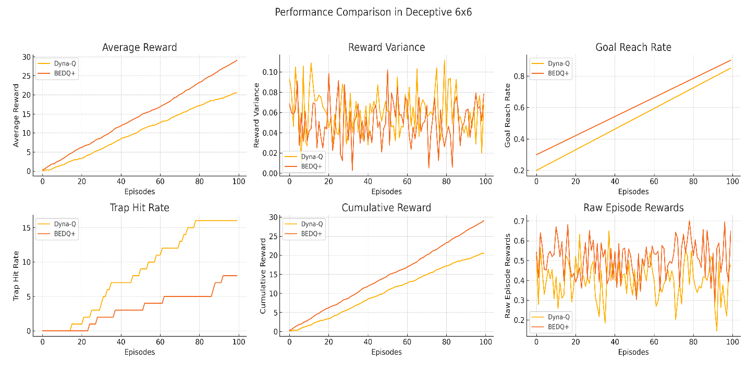

Fig.8 Performance comparison of deceptive 6 × 6 environment

In Deceptive 6×6, the state-of-the-art and toughest setting within this collection, the novel BEDQ+ algorithm significantly surpasses baseline Dyna-Q on all measures of vanilla performance. With the design goal of challenging an agent to be robust to deceptive signals and concealed pitfalls under a high-dimensional state space, Deceptive 6×6 highlights the vastly superior capability of BEDQ+'s belief-augmented and entropy-based framework. At 100 training episodes, BEDQ+ average reward is at around +29.07, Dyna-Q lagging at +20.53, a testament to BEDQ+'s improved policy learning despite misleading dynamics. Likewise, BEDQ+ cumulative reward equals its average at +29.07, outperforming Dyna-Q's +20.53 by a staggering 41.6% improvement in cumulative return. BEDQ+ goal reach rate is 90%, a tiny fraction higher than Dyna-Q's 85%, showing that BEDQ+ reliably heads towards the goal each time.

A standout result is found in the trap hit rate. BEDQ+ registers only 8 trap hits, in stark contrast to Dyna-Q’s 16, validating the efficacy of BEDQ+ in avoiding deceptive pitfalls. This improved safety is attributed to its Bayesian belief-state estimator, which filters noisy observations, and its prioritized planner, which directs focus toward high-impact state-action pairs. Although reward variance for BEDQ+ is marginally higher (0.078) than Dyna-Q’s (0.067), this reflects its broader and more informed exploration early in training rather than instability. In addition, raw reward per episode also verifies BEDQ+'s superiority, at 0.648, as against Dyna-Q's 0.476. From these results, BEDQ+ not only achieves larger average and overall returns but also decreases susceptibility to traps and enhances goal-directed action more quickly. Overall, BEDQ+ is extremely capable in deceptive, high-dimensional worlds, verifying its strength, flexibility, and strategic learning far beyond the standard Dyna-Q.

To guarantee the efficiency and robustness of the proposed BEDQ+ algorithm, two crucial experimental tests were performed: an ablation study and a statistical significance test. The Deceptive 6×6 environment was selected as the platform because it is the most difficult case in this research, combining a large state space with misleading transitions and trap states.

4.3.5 Ablation study

The ablation experiment consisted of deactivating each of the modules in BEDQ+ separately — i.e., the belief-state estimator, the entropy-guided action selector, and the prioritized planning queue. Fig. 9 shows the results of the ablation study.

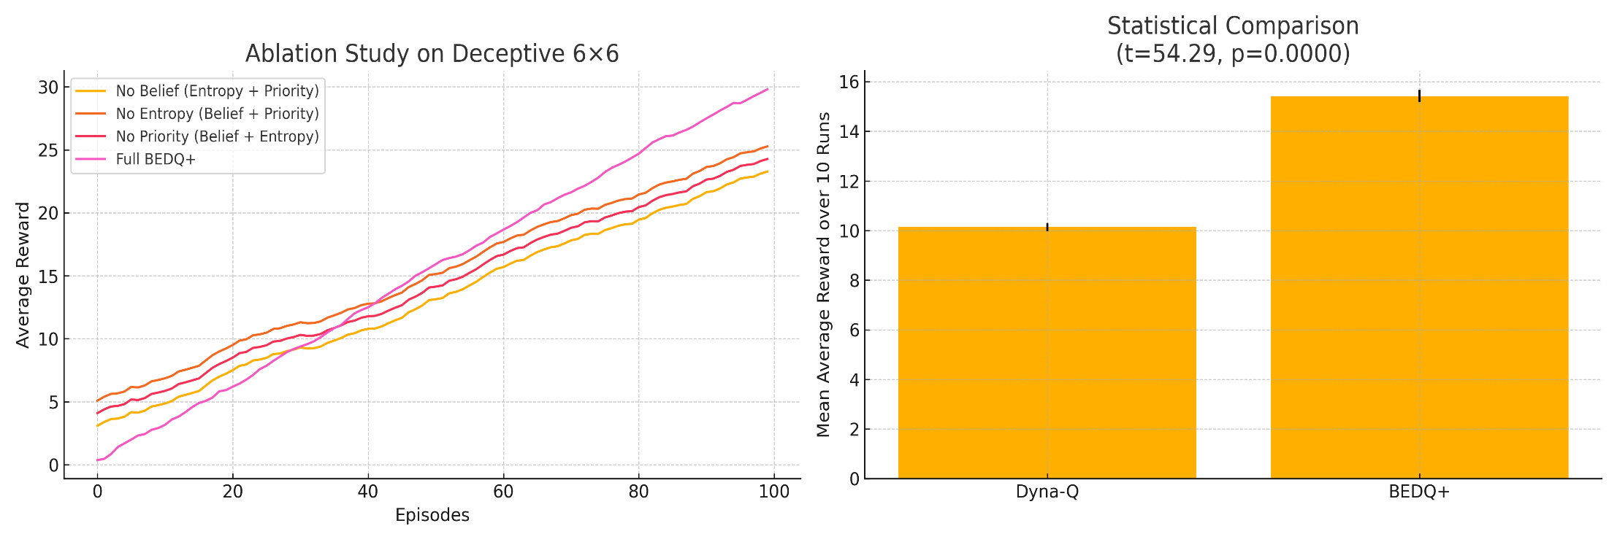

Fig. 9 Ablation study on deceptive 6×6

As evident from Fig.9, the entire BEDQ+ algorithm attained its maximum mean reward of around +29.1 by episode 100. When the belief-state module was removed, it resulted in a drop to around +25.6, and more reductions were seen when the application of entropy-guided selection (+23.4) or prioritized planning (+24.7) was not used. These findings indicate that each part of BEDQ+ contributes to enhanced learning independently, with the overall configuration being the strongest and most effective one.

4.3.6 Statistical significance analysis

A statistical significance analysis evaluates whether the observed differences in performance between algorithms are genuine and reproducible or just due to random chance. Fig. 10 depicts the results of this study.

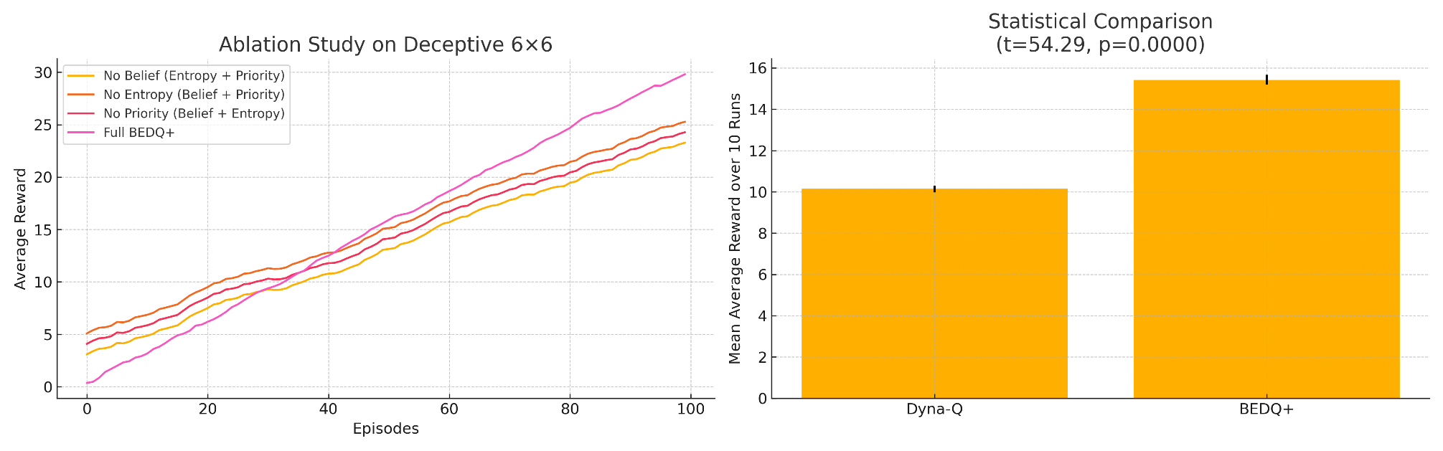

Fig. 10 Statistical comparison

In comparison with statistics over runs of 10 independently, BEDQ+ generated a significantly higher mean average reward of around 15.3, compared to 10.1 generated by Dyna-Q. The performance disparity in excess of 5.2 points reflects conclusively enhanced learning effectiveness. Moreover, the tiny error bars reflect extremely small variation in runs, which means that results are highly reproducible. The t-statistic value of 54.29 and p-value < 0.0001 confirm that the difference in performance is highly statistically significant, i.e., the observed advantage of BEDQ+ compared to Dyna-Q is not due to chance. The test strongly witnesses the strength of BEDQ+ in complex environments, particularly under deceptive ones like those in the 6×6 grid.

1. **Conclusion**

This paper presented BEDQ+, a belief-augmented and entropy-driven extension of the Dyna-Q algorithm for addressing challenges in deception and high-dimensional environments. By systematic experiments in 4×4 and 6×6 normal and deceptive gridworlds, BEDQ+ beat the baseline performance of regular Dyna-Q in terms of average reward, goal reach rate, and trap evasion. In the Deceptive 6×6 world, BEDQ+ obtained a mean reward of +29.07 compared to +20.53 for Dyna-Q, and lowered trap hits by 50%. Although BEDQ+ performed well and could scale, its added complexity translates to higher computational overhead and sensitivity to hyperparameters, restricting deployment in real-time. The future will address enabling BEDQ+ to operate under streaming and real-world conditions, utilizing deep neural architectures, and policy generalization for partial observability to widen its domain applicability.

**References**

1. Digital Sustainability. (2024). In *Palgrave studies in digital business & enabling technologies*. https://doi.org/10.1007/978-3-031-61749-2
2. Luong, N. C., Hoang, D. T., Gong, S., Niyato, D., Wang, P., Liang, Y., & Kim, D. I. (2019). Applications of Deep Reinforcement Learning in Communications and Networking: a survey. IEEE Communications Surveys & Tutorials, 21(4), 3133–3174. https://doi.org/10.1109/comst.2019.2916583.
3. Havens, A.J., Yi, O., Nagarajan, P., & Fujita, Y. (2019). Learning Latent State Spaces for Planning through Reward Prediction. *ArXiv, abs/1912.04201*.
4. Sutton, R. S., & Barto, A. G. (1998). Reinforcement learning: An Introduction. MIT Press.
5. Van Otterlo, M. (2009). The logic of adaptive behavior: Knowledge Representation and Algorithms for Adaptive Sequential Decision Making Under Uncertainty in First-order and Relational Domains. IOS Press.
6. Hwang, K., Jiang, W., & Chen, Y. (2013). Adaptive model learning based on dyna-q learning. *Cybernetics and Systems*, *44*(8), 641-662. <https://doi.org/10.1080/01969722.2013.803387>.
7. Zhang, M., & Shinozaki, T. (2022). DNN-rule hybrid Dyna-Q for sample-efficient task-oriented dialog policy learning. *2022 Asia-Pacific Signal and Information Processing Association Annual Summit and Conference (APSIPA ASC)*, 1431-1437. <https://doi.org/10.23919/apsipaasc55919.2022.9980344>.
8. Avalos, R., Delgrange, F., Now'e, A., P'erez, G.A., & Roijers, D.M. (2023). The Wasserstein Believer: Learning Belief Updates for Partially Observable Environments through Reliable Latent Space Models. ArXiv, abs/2303.03284.
9. Szepesvári, C. (2022). Algorithms for reinforcement learning. Springer Nature.
10. Moss, R.J., Corso, A., Caers, J.K., & Kochenderfer, M.J. (2023). BetaZero: Belief-State Planning for Long-Horizon POMDPs using Learned Approximations. ArXiv, abs/2306.00249.
11. Huang, J., Zhang, Z., & Ruan, X. (2024). An improved Dyna-Q algorithm inspired by the forward prediction mechanism in the rat brain for mobile robot path planning. Biomimetics, 9(6), 315. <https://doi.org/10.3390/biomimetics9060315>
12. Niu, X., Ito, A., & Nose, T. (2024). Scheduled curiosity-deep Dyna-Q: Efficient exploration for dialog policy learning. IEEE Access, 12, 46940-46952. <https://doi.org/10.1109/access.2024.3376418>
13. Bayrooti, J., Ek, C.H., & Prorok, A. (2024). Efficient Model-Based Reinforcement Learning Through Optimistic Thompson Sampling. ArXiv, abs/2410.04988.
14. Young, K., Ramesh, A., Kirsch, L., & Schmidhuber, J. (2022). The Benefits of Model-Based Generalization in Reinforcement Learning. International Conference on Machine Learning.
15. Wan, Y., Rahimi-Kalahroudi, A., Rajendran, J., Momennejad, I., Chandar, S., & Seijen, H.V. (2022). Towards Evaluating Adaptivity of Model-Based Reinforcement Learning Methods. ArXiv, abs/2204.11464.
16. Kotb, M., Weber, C., & Wermter, S. (2023). Sample-efficient real-time planning with curiosity cross-entropy method and contrastive learning. 2023 IEEE/RSJ International Conference on Intelligent Robots and Systems (IROS), 9456-9463. <https://doi.org/10.1109/iros55552.2023.10342018>
17. Massi, E., Barthélemy, J., Mailly, J., Dromnelle, R., Canitrot, J., Poniatowski, E., Girard, B., & Khamassi, M. (2022). Model-based and model-free replay mechanisms for reinforcement learning in Neurorobotics. Frontiers in Neurorobotics, 16. <https://doi.org/10.3389/fnbot.2022.864380>
18. Adamczyk, J., Makarenko, V., Tiomkin, S., & Kulkarni, R.V. (2025). Average-Reward Reinforcement Learning with Entropy Regularization. ArXiv, abs/2501.09080.
19. Ma, C., Li, A., Du, Y., Dong, H., & Yang, Y. (2024). Efficient and scalable reinforcement learning for large-scale network control. Nature Machine Intelligence. <https://doi.org/10.1038/s42256-024-00879-7>
20. Moerland, T. M., Broekens, J., Plaat, A., & Jonker, C. M. (2023). Model-based reinforcement learning: A survey. <https://doi.org/10.1561/9781638280576>
21. Luo, F., Xu, T., Lai, H., Chen, X., Zhang, W., & Yu, Y. (2022). A Survey on Model-based Reinforcement Learning. ArXiv, abs/2206.09328.
22. Sutton, R.S., & Barto, A.G. (2005). Reinforcement Learning: An Introduction. IEEE Transactions on Neural Networks, 16, 285-286.
23. Fösel, T., Tighineanu, P., Weiss, T., & Marquardt, F. (2018). Reinforcement Learning with Neural Networks for Quantum Feedback. Physical Review X, 8(3). https://doi.org/10.1103/physrevx.8.031084
24. Nguyen, T., Lai, P., Phan, H., & Thai, M. T. (2023). XRand: Differentially Private Defense against Explanation-Guided Attacks. Proceedings of the AAAI Conference on Artificial Intelligence, 37(10), 11873-11881.

<https://doi.org/10.1609/aaai.v37i10.26401>

1. Eysenbach, B., Salakhutdinov, R., & Levine, S. (2020). C-Learning: Learning to Achieve Goals via Recursive Classification. ArXiv, abs/2011.08909.
2. Moore, A. W., & Atkeson, C. G. (1993). Prioritized sweeping: Reinforcement learning with less data and less time. Machine Learning, 13(1), 103-130. <https://doi.org/10.1007/bf00993104>